Data Science

Mini Project Report On

Fake News Detector Using Machine Learning

(A.Y 2024-2025)
PREPARED BY

Name | ID
Anand Dane | VU4F2223094
Swaroop Sawant | VU4F2223100
Prathamesh Thakare | VU4F2223103
Omkar Patil | VU4F2223108

Under the guidance of
Dr. Vinod Sapkal
Assistant Professor

Department of Information Technology Vasantdada Patil
Pratishthan's College of Engineering & Visual Arts
UNIVERSITY OF MUMBAI
(AY 2025-26)

CERTIFICATE

This is to certify that the project entitled “Fake News Detector Using Machine Learning” is bonafide work of Anand Dane vu4f2223094, Swaroop Sawant vu4f2223100, Omkar Patil vu4f2223108, Prathamesh Thakare vu4f2223103, submitted to University of Mumbai in partial fulfillment of requirement for the award of degree of “Bachelor of Engineering in Information Technology-Semester-VII”

Dr. Vinod Sapkal
Guide
Assistant Professor

Dr. Pradip Mane Dr. Alam N. Shaikh
Head of Department(IT) Principal

ABSTRACT

In today’s digital world, information spreads faster than ever especially through social media and online news platforms. While this has made access to news easier, it has also opened the door for the rapid spread of fake or misleading news. These false stories can create confusion, influence public opinion negatively and even lead to real-world consequences. This project focuses on developing a Fake News Detection System using Machine Learning techniques. With the increasing use of online platforms, misinformation spreads rapidly, influencing public perception.
The system leverages Natural Language Processing (NLP) and classification algorithms to automatically identify whether a given news article is genuine or fake. The project uses TF-IDF vectorization to extract features from textual data and Logistic Regression for classification. This approach effectively captures linguistic patterns, distinguishing fake news from real news articles. The proposed model demonstrates that even simple algorithms, when trained with appropriate text
preprocessing and feature extraction methods, can yield high accuracy. This project contributes to the ongoing efforts of combating misinformation and promoting authenticity in digital news media.

INTRODUCTION

In today’s digital era, the fast-paced growth of online platforms has transformed how people access and share information. However, this digital revolution has also fueled the rapid spread of misinformation and fake news. Detecting fake news manually is infeasible given the enormous volume of data generated daily across websites, blogs, and social-media.
Therefore, developing an automated system using Machine Learning to detect fake or misleading information has become essential. The Fake News Detection System aims to identify false information by analyzing textual content using Natural Language Processing and classification techniques. The project’s goal is to reduce misinformation by building a reliable model that distinguishes between real and fake news articles.

PROPOSED SYSTEM

The proposed Fake News Detection System uses supervised machine learning methods to classify news articles as real or fake. The process includes dataset analysis, text preprocessing, feature extraction using TF-IDF, and classification using Logistic Regression.
The model analyzes linguistic patterns in news content to identify misleading or exaggerated writing styles commonly found in fake news.

System Objectives:
1. To collect and preprocess real-world news datasets containing fake and real news articles.
2. To perform text preprocessing such as removing punctuation, URLs, and stopwords.
3. To convert textual data into numerical features using TF-IDF Vectorization.
4. To train and test classification models (Logistic Regression) for fake news detection.
5. To evaluate performance using accuracy, precision, recall, and F1-score.
6. To build a user interface for easy testing of news authenticity.

METHODOLOGY

The methodology of the Fake News Detection System consists of several steps:

Data Collection-

Gather datasets of labeled news articles (real/fake).

Data Preprocessing-

Remove special characters, punctuation, URLs, and perform tokenization and stopword removal.

Feature Extraction-

Use TF-IDF Vectorizer to convert text into numerical representations.

Model Training -

Train the Logistic Regression classifier on processed TF-IDF features.

Evaluation -

Evaluate the model on unseen data to test its ability to generalize.

Deployment -

Implement the trained model using Streamlit for real-time detection of fake news.

About the dataset :

The dataset used in this project contains a collection of news articles, divided into two categories: real and fake. The main goal is to analyze the content of these articles and build a model that can predict whether a given piece of news is genuine or misleading.
Each article in the dataset includes details like the title, the full text of the article, its subject, and the date it was published. For the purpose of this project, a new column called ‘class’ was added to help label the data with 0 representing fake news and 1 representing real news.
By combining both fake and real articles, this dataset allows us to train a machine learning model to detect patterns in the text that can help identify misinformation. The focus is on using the text content of the news itself to make predictions, which can be especially useful in flagging suspicious or misleading articles online.

Algorithms used:

Logistic Regression (Supervised Learning):

Logistic Regression is a simple yet effective classification algorithm that is often used for binary classification problems like detecting whether news is real or fake. It works by finding the best-fit line (or decision boundary) that separates the two classes based on the input features. Despite its simplicity, Logistic Regression can perform very well when combined with proper feature extraction techniques like TF-IDF.

In this project, Logistic Regression was trained on TF-IDF vectorized text data, which captures the importance of words across the dataset. The model showed good accuracy and was able to generalize well on the test data. Its performance confirmed that even a linear model, when paired with strong textual features, can effectively detect patterns in writing styles that often distinguish fake news from real articles.

TF-IDF Vectorizer (Feature Extraction):

Although not a learning algorithm by itself, the TF-IDF (Term Frequency–Inverse Document Frequency) vectorizer plays a crucial role in converting text data into numerical form so that machine learning models can work with it. It assigns weights to words based on how frequently they appear in a document versus across all documents, allowing the model to focus on terms that carry more informative value.

In the context of fake news detection, TF-IDF helps highlight key differences in word usage between fake and real articles. For instance, fake news may use more exaggerated or sensational language, while real news tends to be more neutral and structured. This vectorization step is essential for extracting those subtle differences and feeding them into the classification model.

Implementation

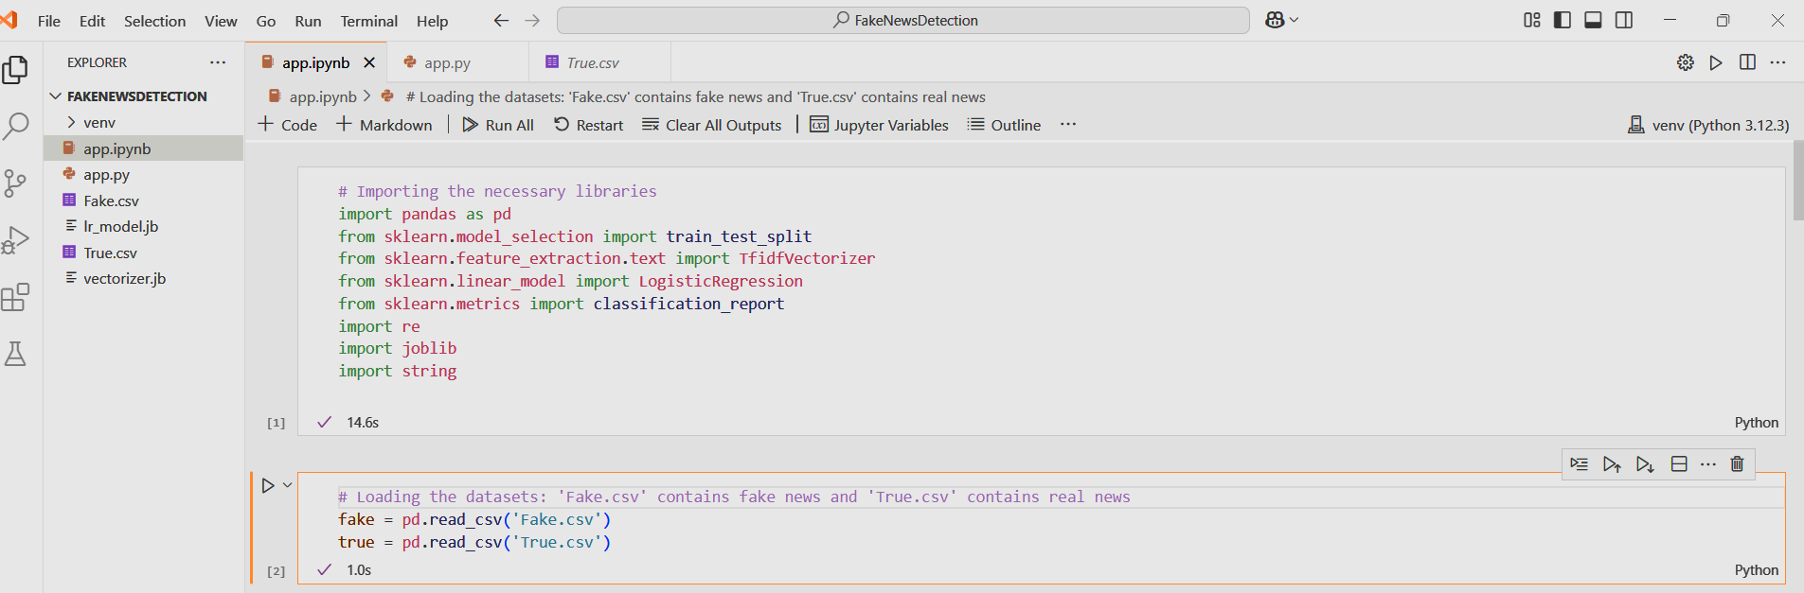

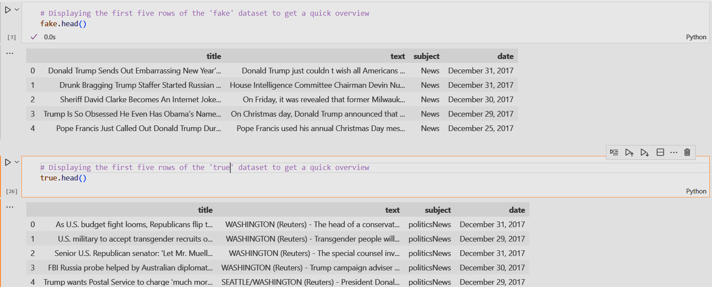

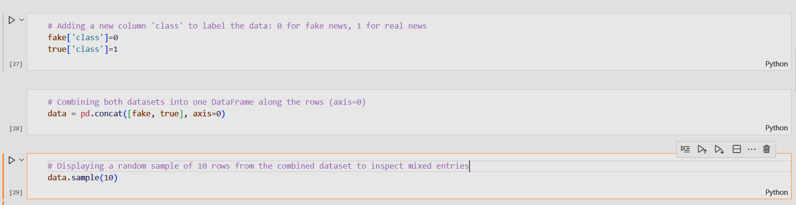

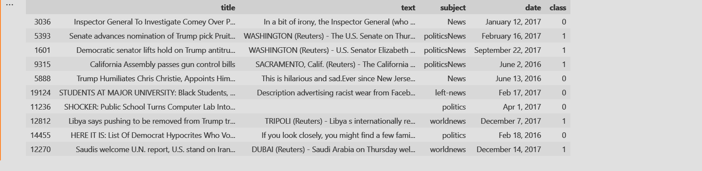

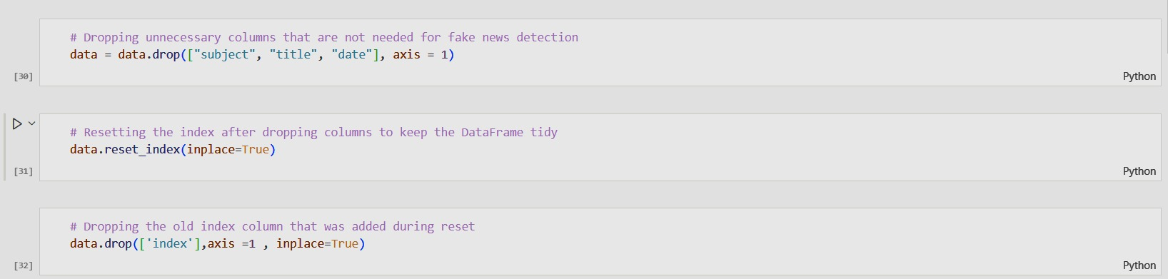

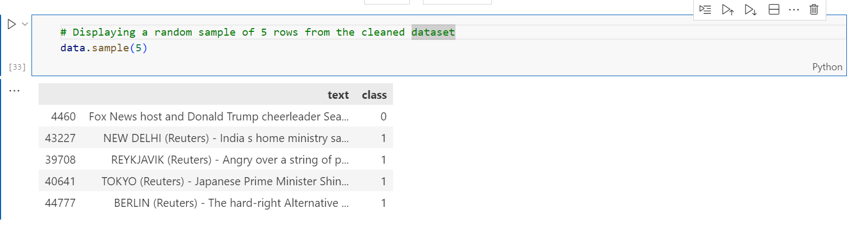

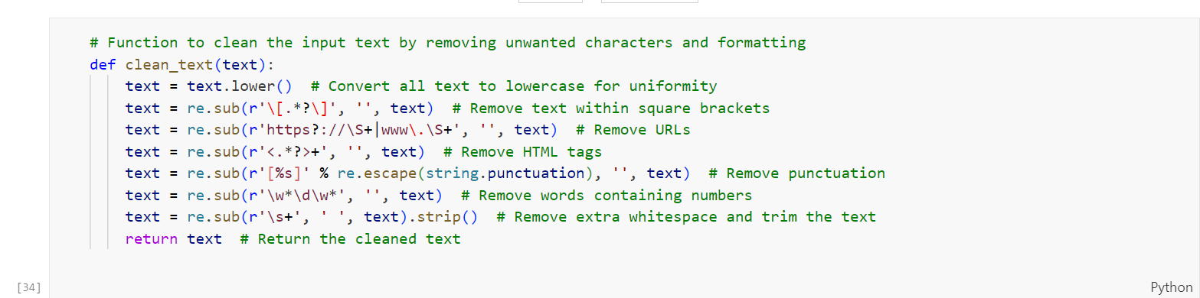

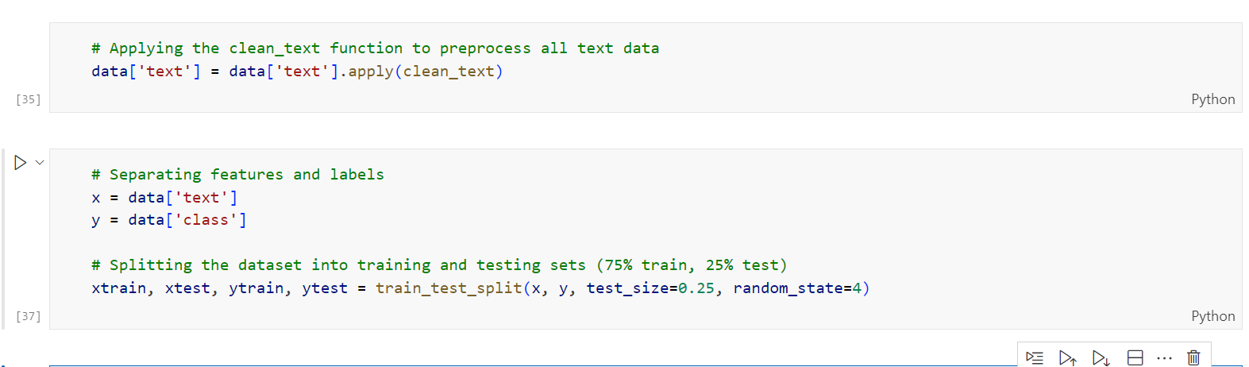

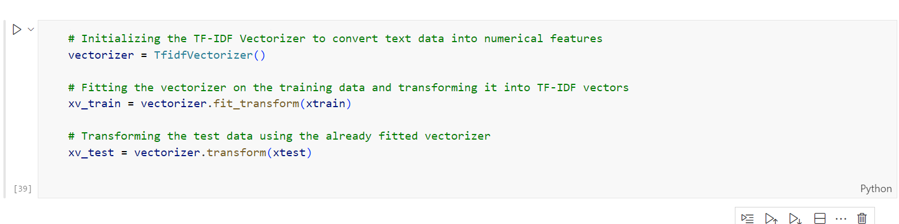

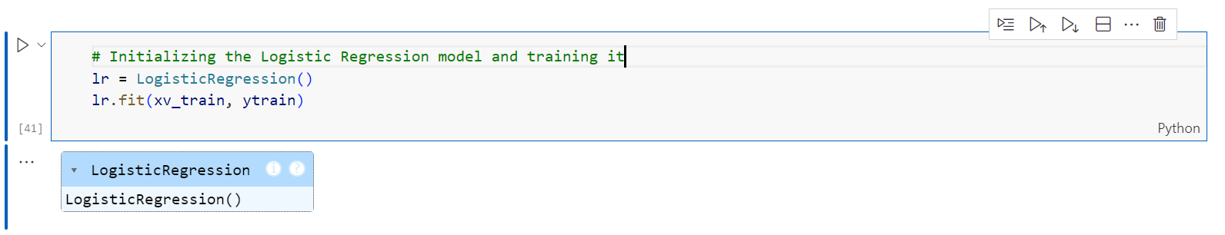

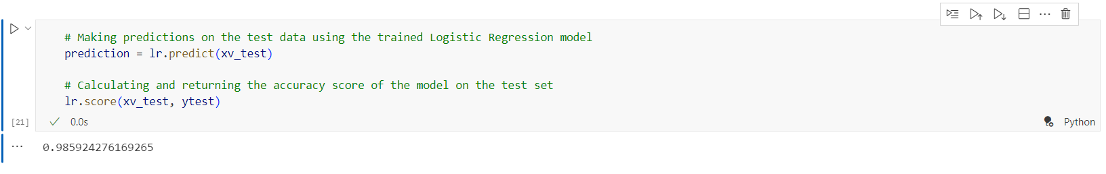

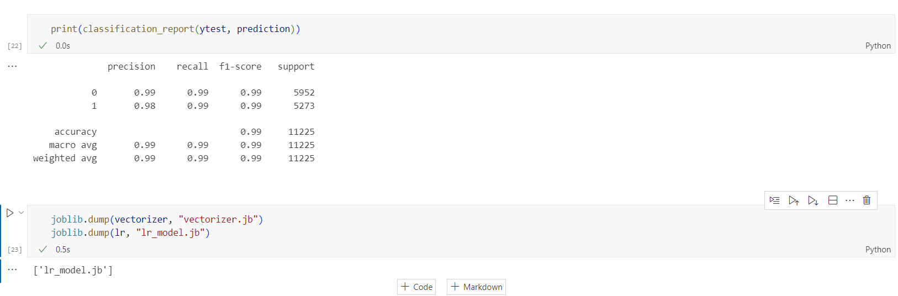

User Interface:-

import streamlit as st
import joblib

vectorizer = joblib.load("vectorizer.jb")
model = joblib.load("lr_model.jb")

st.title("Fake News Detector")
st.write("Enter a News Article below to check whether it is Fake or Real. ")

inputn = st.text_area("News Article:","")

if st.button("Check News"):
if inputn.strip():
transform_input = vectorizer.transform([inputn])
prediction = model.predict(transform_input)

if prediction[0] == 1:
st.success("The News is Real! ")
else:
st.error("The News is Fake! ")
else:
st.warning("Please enter some text to Analyze. ")

Output:



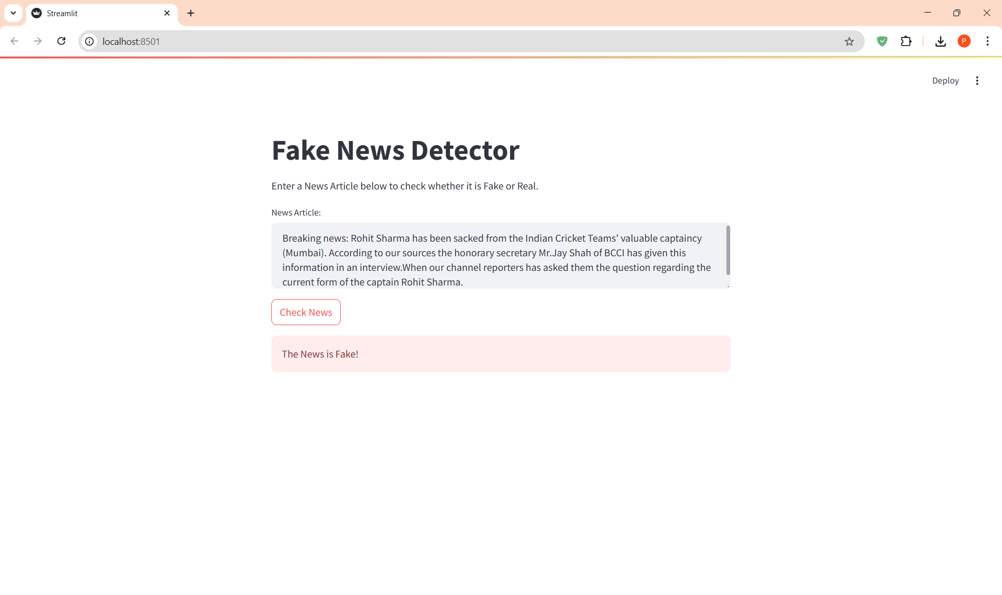

Observations:

- The Logistic Regression model performed well in classifying news articles as real or fake, showing solid accuracy on the test data.
- Text cleaning and preprocessing (such as removing punctuation, URLs) played a crucial role in improving model performance by reducing noise in the data.
- The use of TF-IDF Vectorization helped highlight important words and patterns in the text, allowing the model to better distinguish between fake and real news based on word frequency and relevance.
- The model was able to learn noticeable differences in language style and content structure, with fake news articles often using more emotionally charged or misleading language compared to real ones.
- Overall, combining proper text preprocessing with a lightweight, interpretable model like Logistic Regression proved to be an effective approach for the fake news detection task.

Conclusion:

Thus, we have successfully built and implemented a Fake News Detection system using machine learning techniques. The project demonstrates how effective text preprocessing and feature extraction methods like TF-IDF, combined with a classification model such as Logistic Regression, can accurately distinguish between real and fake news articles.
By cleaning and analyzing the content of the news, we were able to train a model that captures the subtle patterns in language and writing style commonly found in misleading information. This kind of system can be a valuable tool in today’s digital age, where misinformation spreads quickly across online platforms. Overall, the project highlights the potential of data science in addressing real-world challenges like fake news detection.

